Flat Wire Machine – .Net Applications

Search Customers: Existing B2B dropdown needs to be renamed as "Type". It should contain "Regular Orders", "B2B" and "Flat Wire". As how the field turns green when B2B is selected, likewise it should turn pink when "Flat Wire" is selected. Orders of selected type should only be shown.
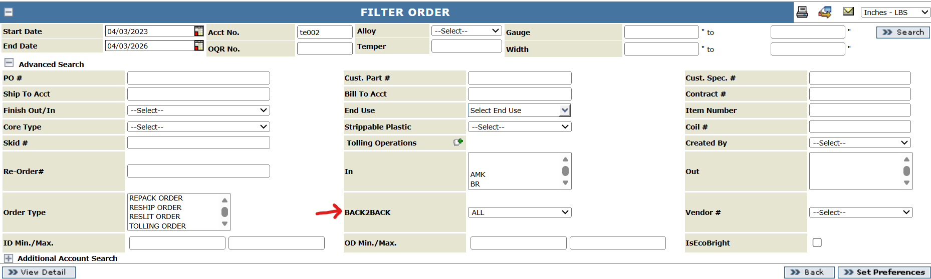

Order and Quotes screens:
Add a checkbox called "Flat Wire".
When "Flat Wire" checkbox is selected, a new field called "Bundle Width" will be shown, which would two textboxes, to show a range of values Min and Max. Bundle Width (both Min and Max) are mandatory, if "Flat Wire" checkbox is selected.
Add a new field called "Edge Type" with a dropdown shown. To start with, dropdown will contain values Round Edge and Flat Edge.
Auto-population of pricing fields will be determined later on, when more information is available.

Should the finish be open for users to change? Or should it be fixed same like B2B? Tim – I would leave it fixed for now as we do not have different rolls to change or affect finish. 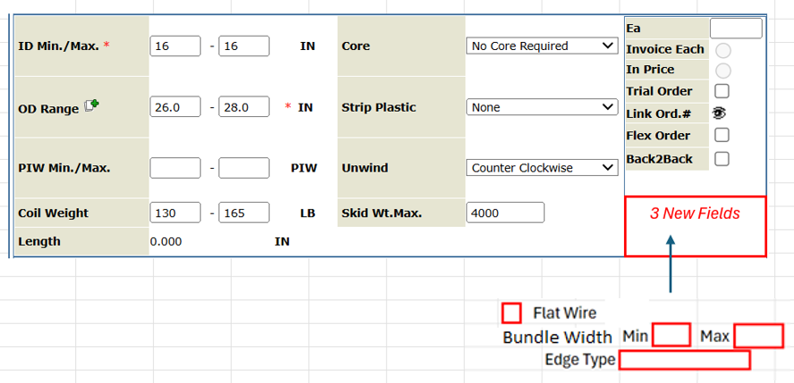
Tim – updated bundle id to bundle width in screen shot.

IQR/Item:
Add a checkbox called "Flat Wire".
Add new field called "Bundle Width", which would be a range of values Min and Max. Bundle Width (both Min and Max) are mandatory, if "Flat Wire" checkbox is selected.
Add a new field called "Edge Type" with a dropdown shown. To start with, dropdown will contain values Round Edge and Flat Edge.
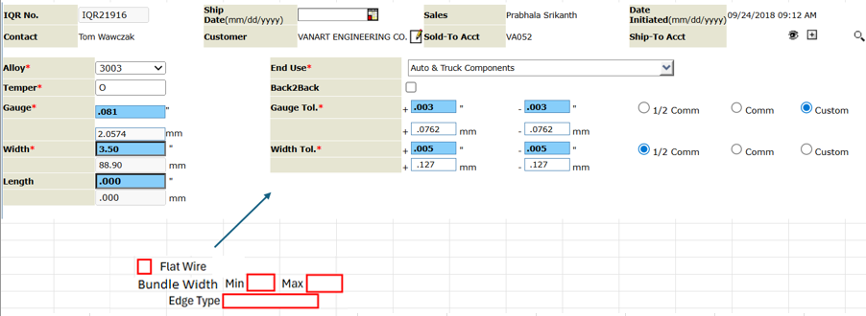

Tim – updated bundle id to bundle width in screen shot.

In Part & Product Details tab, automatically set the "Edge" critical attribute in Part & Product Details to "5 - Edge not a consideration" because this is slit related and does not apply to flat wire. Specifications should be populated with only those that correspond to the flat wire option, if chosen.

Should the finish be open for users to change? Or should it be fixed same like B2B? Tim – I would leave it fixed for now as we do not have different rolls to change or affect finish.

Item Template – SMP Creation:
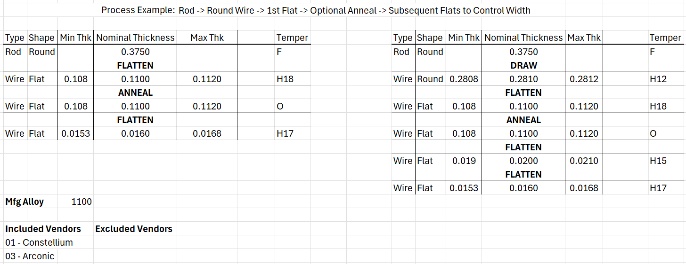

Based on the manufacturing alloy and its Vendor O Gauges details, populate the included/excluded vendors.
User can create the process, same as existing approach, except that two new columns need to be added – Type and Shape. Everything else should remain the same.

Alloys:
- Properties tab: Add a dropdown called “Material Type” to the left of “Unit Of Measurement”. Former will contain values “Coils”, “Flat Wire”, etc.
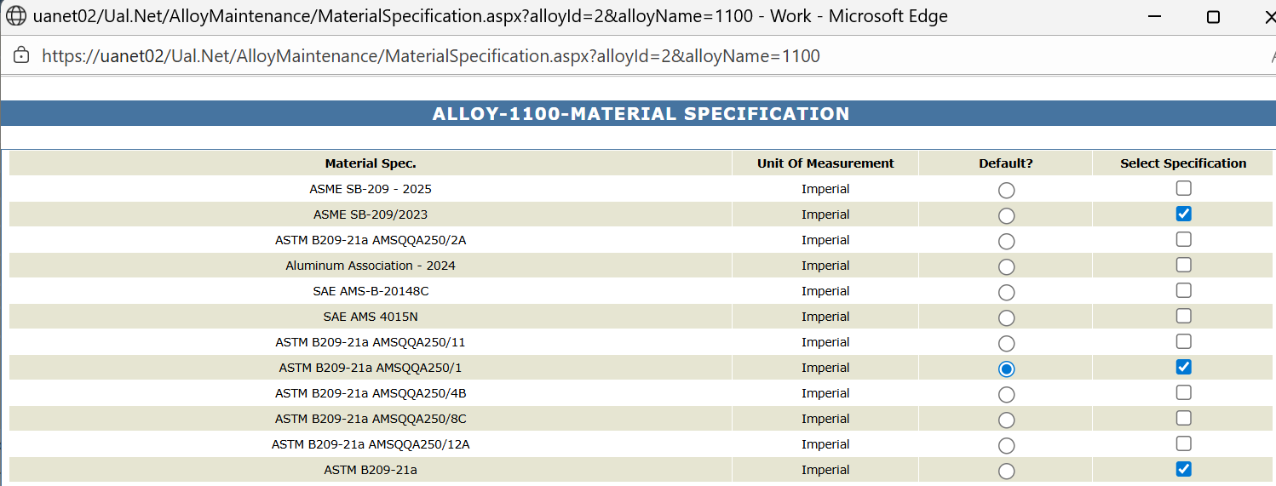

- Reduction Rules tab: Add a dropdown called “Material Type” will be added. Existing data will be shown under the type “Coils – Reduction Rules”, and whereas for the new type “Rod/Wire – Reduction Rules”, data will be shown in following format:
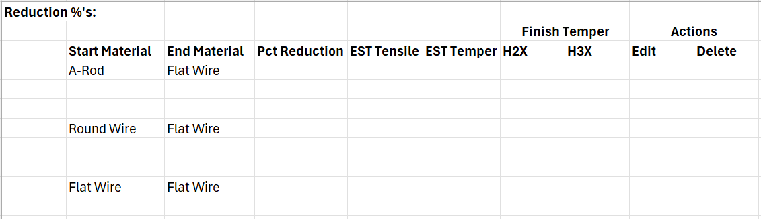

- Mech Test Limit: No change.
- Anneal Cycle: Add a new entry for flat wire.
- Vendor O Gauge: Same as the “Reduction Rules” tab mentioned above, add a dropdown called “Material Type”. Existing data will be shown under the type “Coils – Vendor O Gauges”, and whereas for the new type “Rod/Wire – Vendor O Gauges”, data will be shown in the same format as existing tab.

Account Maintenance: No changes.

Vendor Maintenance: Add a checkbox called “Flat Wire” to indicate that the vendor can supply flat wire product. This should be between Reroll and Scrap checkboxes. Material preferences/qualifications can be defined as done currently.

Scrap Sales: WIP

CFRs: No changes.

Samples Report: No changes.

Certs: No changes.

